EXERCISE 6
1. Order all employees on the basis of the salary they draw.
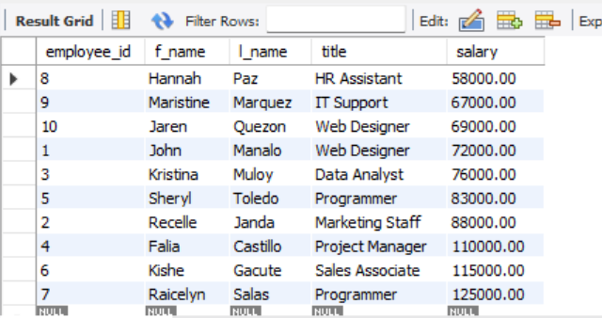
SELECT employee_id, f_name, l_name, title, salary FROM employee_data ORDER BY salary;

2. List all employees in descending order of their years of service.
SELECT employee_id, f_name, l_name, yearsofservice FROM employee_data ORDER BY yearsofservice DESC;
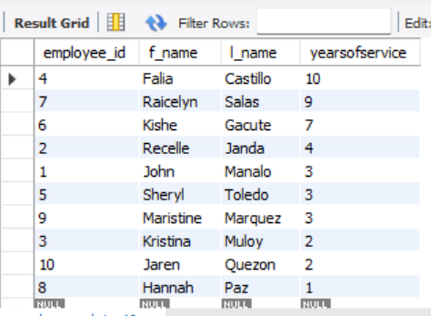

3. What does the following statement display?
SELECT employee_id, l_name, title, age FROM employee_data ORDER BY title DESC, age ASC;
It display all employee id including last name sorted primarily by job title in descending order, and within the title it sorted by age in ascending order.
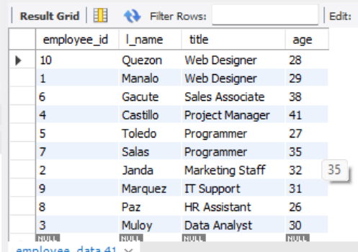

4. Display employees (last names followed by first names) who hold the title of either “Programmer” or “Web Designer” and sort their last names alphabetically.
SELECT CONCAT(l_name, ', ', f_name) AS full_name, title FROM employee_data WHERE title IN ('Programmer','Web Designer') ORDER BY l_name ASC;
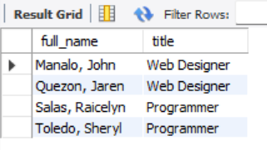

CREATE DATABASE Exercise6_ADDRESSBOOK;
USE Exercise6_ADDRESSBOOK;
CREATE TABLE employee_data (
employee_id INT AUTO_INCREMENT PRIMARY KEY,
f_name VARCHAR(100),
l_name VARCHAR(100),
title VARCHAR(100),
division VARCHAR(100),
age INT,
yearsofservice INT,
salary DECIMAL(10,2),
perks DECIMAL(10,2),
email VARCHAR(100)
);
INSERT INTO employee_data (f_name, l_name, title, division, age, yearsofservice, salary, perks, email) VALUES
('John', 'Manalo', 'Web Designer', 'IT', 29, 3, 72000, 3500, 'aaron.lopez@bignet.com'),
('Recelle', 'Janda', 'Marketing Staff', 'Marketing', 32, 4, 88000, 6000, 'bianca.santos@bignet.com'),
('Kristina', 'Muloy', 'Data Analyst', 'IT', 30, 2, 76000, 4500, 'celine.torres@bignet.com'),
('Falia', 'Castillo', 'Project Manager', 'Operations', 41, 10, 110000, 16000, 'darren.castillo@bignet.com'),
('Sheryl', 'Toledo', 'Programmer', 'IT', 27, 3, 83000, 9000, 'elaine.mendoza@bignet.com'),
('Kishe', 'Gacute', 'Sales Associate', 'Sales', 38, 7, 115000, 19000, 'francis.diaz@bignet.com'),
('Raicelyn', 'Salas', 'Programmer', 'IT', 35, 9, 125000, 20000, 'gwen.reyes@bignet.com'),
('Hannah', 'Paz', 'HR Assistant', 'HR', 26, 1, 58000, 3000, 'hannah.lim@bignet.com'),
('Maristine', 'Marquez', 'IT Support', 'IT', 31, 3, 67000, 3200, 'ivan.ramirez@bignet.com'),
('Jaren', 'Quezon', 'Web Designer', 'IT', 28, 2, 69000, 2800, 'jared.flores@bignet.com');

SELECT employee_id, f_name, l_name, title, salary FROM employee_data ORDER BY salary;
SELECT employee_id, f_name, l_name, yearsofservice FROM employee_data ORDER BY yearsofservice DESC;
SELECT employee_id, l_name, title, age FROM employee_data ORDER BY title DESC, age ASC;
SELECT CONCAT(l_name, ', ', f_name) AS full_name, title FROM employee_data WHERE title IN ('Programmer','Web Designer') ORDER BY l_name ASC;

